Bernoulli Distribution:

Definition: The Bernoulli distribution is the simplest discrete probability distribution. It represents the probability distribution of a random variable that has exactly two possible outcomes: success (with probability p) and failure (with probability 1-p). It is used to model binary outcomes, such as coin flip or a yes/no question.   
It is plotted with the help of Probability mass function.

Example: Tossing a coin, Whether the person will pass or fail.

P(X=H) = 0.5 = p

P(X=T) = 1-0.5 = q

Parameters:

0 $≤p ≤1$

q = 1 – p

K = {0,1}. Indicates two outcomes

Let P(success) be K=1

Let P(fail) be K=0

Probability Mass Function:

A company has launched a new smartphone,

Useful = 60% = p

Not useful = 40% = 1-p = q

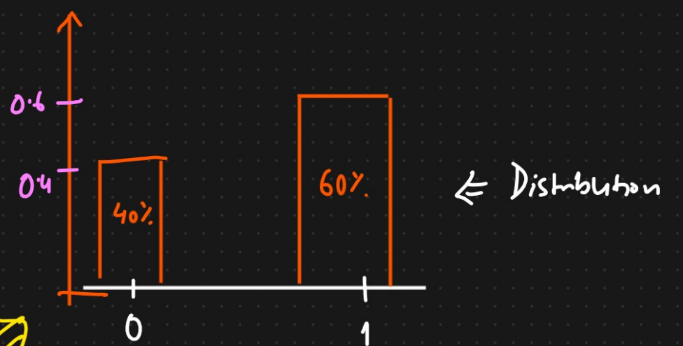

PMF = $P^{K}*{(1-p)}^{1-K}$

This is the formula to create the PMF

If K = 1,

P(K=1) = $P^{1}$ ${(1-p)}^{1-1}$\* = P

P(K=0) = $P^{0}$ ${(1-p)}^{1-0}$\* = 1-p = q

Simplified format to create the pmf:

pmf = $\left\{\begin{aligned}q=1-p, if K=0 \\ p, if K=1 \end{aligned}\right.$

Mean of Bernoulli distribution:

Example:



In order to calculate the mean, we calculate the expected value of X.

E(X) = $\sum_{K=0}^{1 }{K.p(k)}$

K = {0,1}

= 0 x 0.4 + 1 x 0.60

= 0.60 = p

P(1) = 0.6

P(0) = 0.4

Expected mean that we get is nothing but the p value

Median of Bernoulli Distribution:

Median = $\left\{\begin{aligned}0 if p<1/2 \\ \left[0,1\right]if p=\frac{1}{2} \\ 1 if p>1/2 \\ \end{aligned}\right.$

Simplified version:

Median = 0 if q > p

Median = 0.5 if q = p

Median = 1 if q < p

Mode for the Bernoulli Distribution:

If p > q, p will be the mode

Else q will be the mode

Variance for the Bernoulli Distribution:

We know K = 0 and 1. P(K=0) = 0.4 = q and P(K=1) = 0.6 = p.

σ² = P(K=0) ${(K=0 – Mean)}^{2}$\* + = P(K=1) ${(K=1 – Mean)}^{2}$

\*

σ² = 0.40 ${(0 –0.6)}^{2}$\* + 0.6 ${(1 – 0.6)}^{2}$

\*

σ² = 0.24 = P(K=0) \* P(K=1)

σ² = p \* q

σ = $\sqrt{pq}$ = Standard deviation